How to create a custom round?
V2
In this example we will create a custom World Archery type scoring outdoor round, called the Geraldine 30/720, which consists of 72 arrows shot at 30m on a 122cm face. The 72 arrows will be shot in two groups of 36 arrows.
- Navigate to the Plot Tab

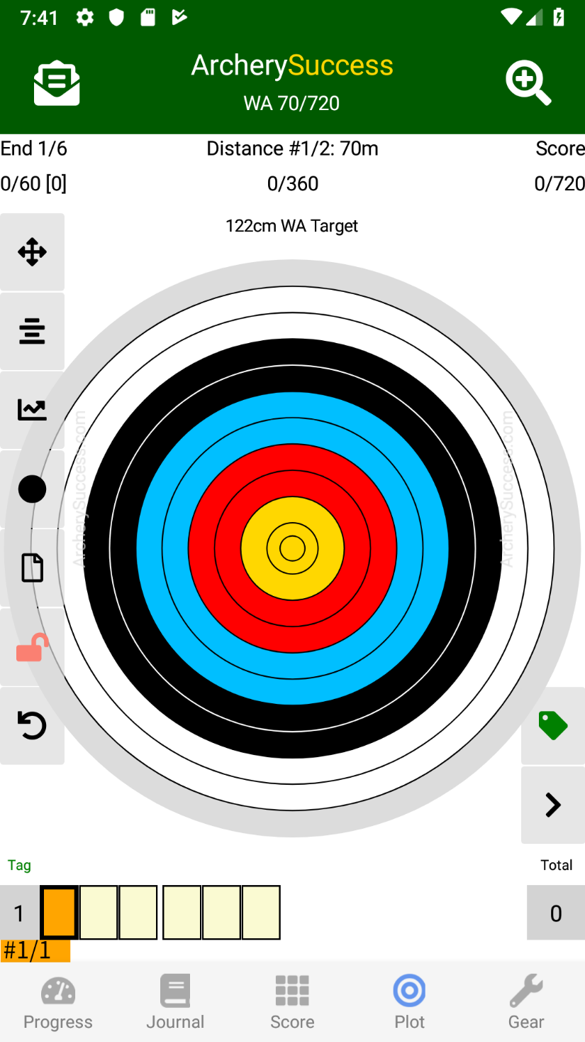

Tap on the Select a round page,  button

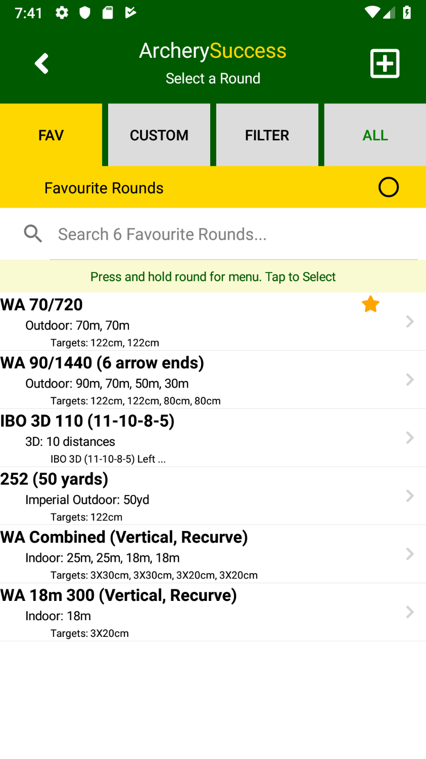

- Tap on the  to open the Custom Round page
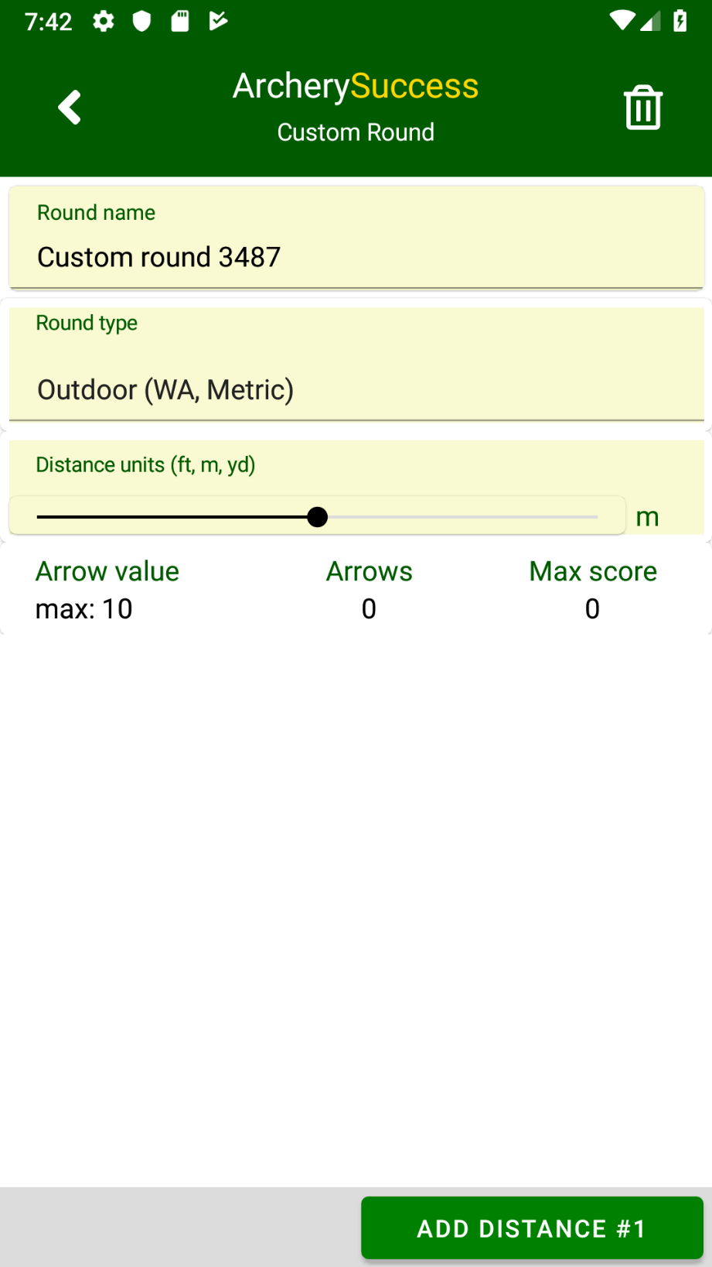

- For the Geraldine 30/720, we will be using Metric scoring, e.g. X, 10, 9, 8… and a WA 122cm target face, which means we don’t need to change the Round Type
- Next change the Round Name to Geraldine 30/720
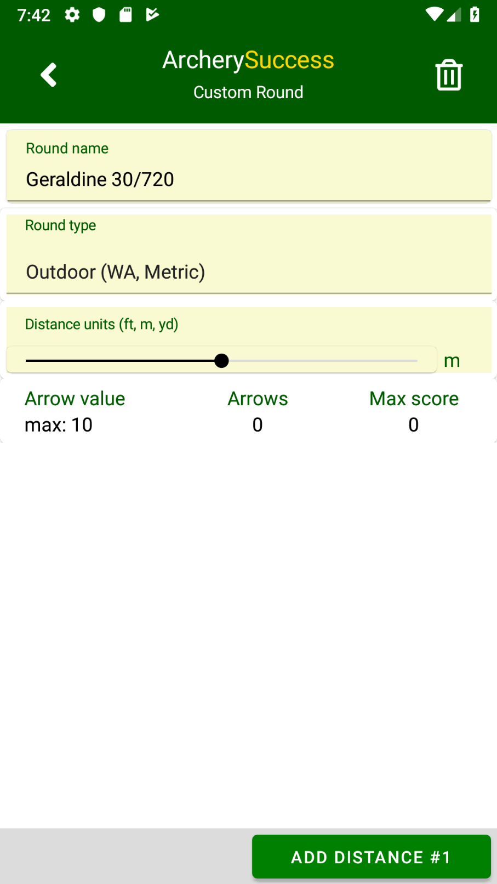

- Next, we want to add two distances to be shot at 30m, each consisting of 6 ends of 6 arrows. Shot on a 122cm target face.

Tap Add Distance #1 to add the first distance

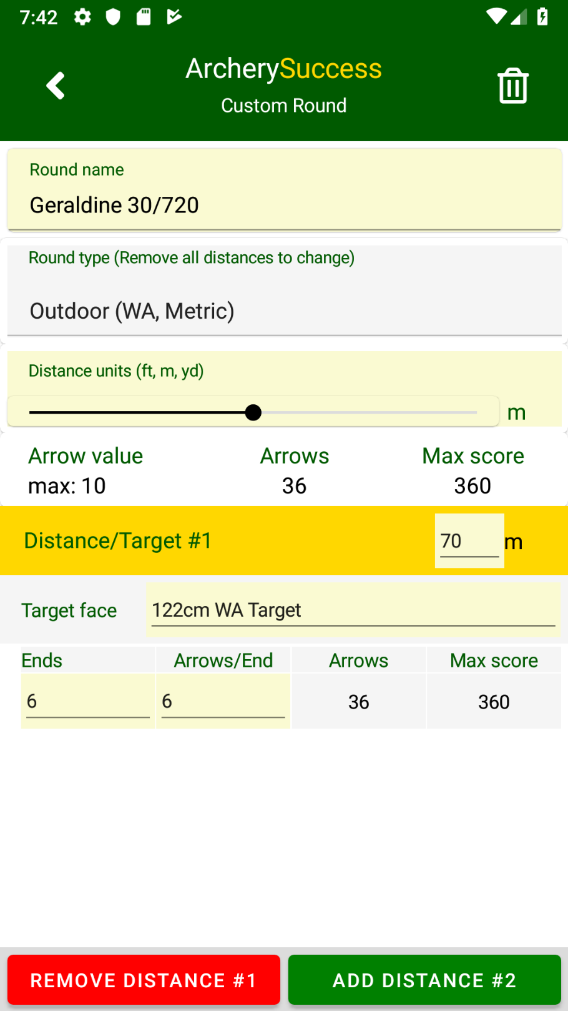

- Change the Distance to 30m
For this example, the default Target Face, Ends and Arrows/End is already as desired.
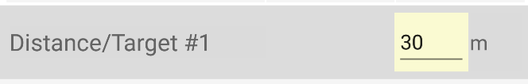

- Tap the Add Distance #2 button to add the 2nd distance

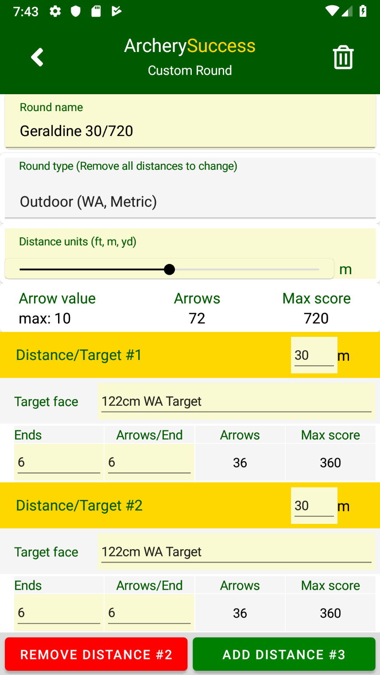

The 2nd distance will be a copy of the first distance, there is no need to change any of the information, and the round is now configured as we want it to be.

- After checking all the round details.
Tap the  to save the new custom round.

Note: At this time saved custom rounds cannot be edited. To make a change to a saved round, the only option is to delete the round and recreate it

- The Geraldine 30/720 round now appears in the round list

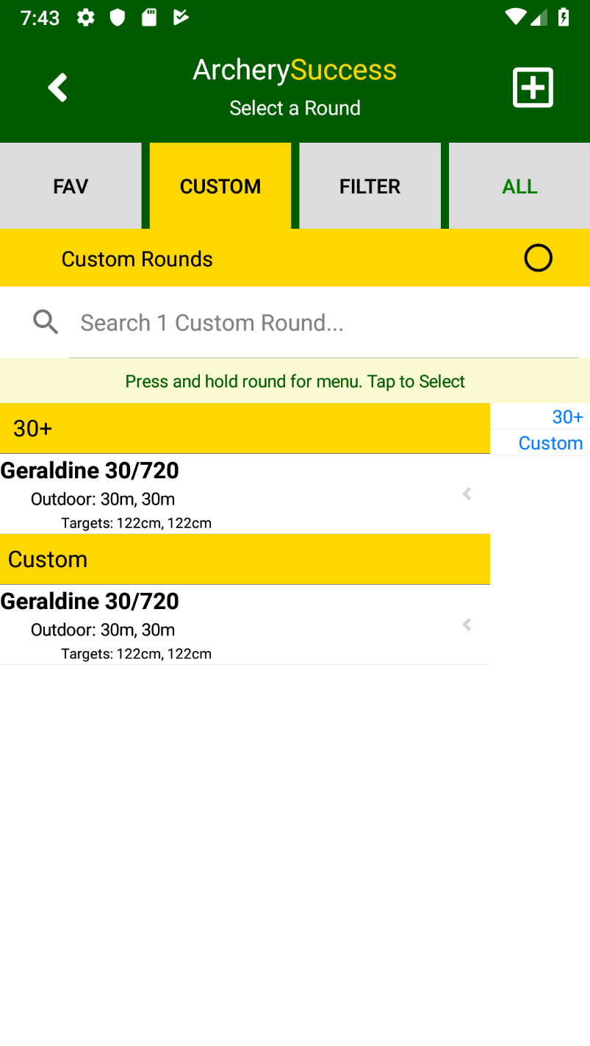

- To delete a custom round;
  - On Android, long press the round name to show the menu and tap detail

  - On iOS (iPhone, iPad) slide the round name left to show the menu and tap detail.

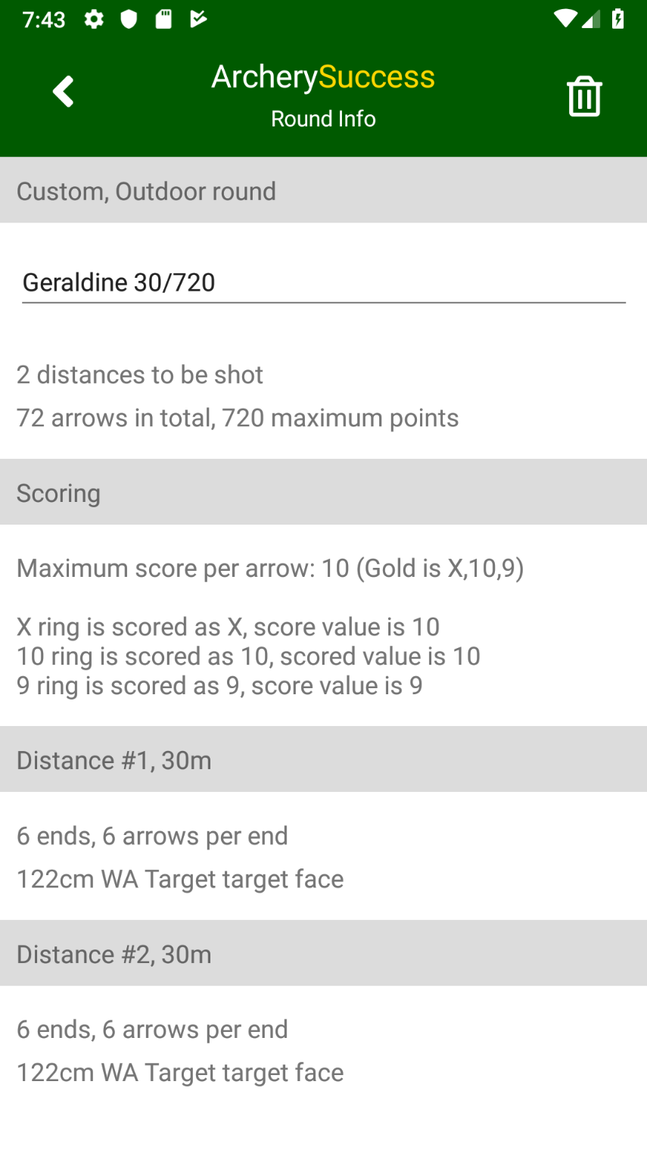

To delete the round, tap the  button

